
Meanwood Church of England Primary School
[DRAFT] Admissions Policy 2027-8
Introduction
This document sets out the admission arrangements of Meanwood Church of England Primary School. Meanwood Church of England Primary School is Voluntary-Aided and, for the purposes of this policy, the Governing Body is the admission authority.
Process
- Applications for admission to the school should be made using the Local Authority Common Application Form by the national closing date of 15th January.
- The Local Authority will inform parents of the offer of a place on behalf of the Governing Body on the national offer date 16th April or the next working day.
- The Meanwood Church of England Primary School has an admission number of 30 pupils for entry into Reception. The school will accordingly admit at least 30 each year if sufficient applications are received. All applicants will be admitted if 30 or fewer apply. There is an intake of new pupils every September into Reception class, for children who will turn 5 between 1 September and 31 August.
- The school will admit any pupils with an Education, Health and Care plan naming the school will automatically be allocated a place. This is a statutory entitlement under s.324 of the Education Act 1996 and is not part of the oversubscription policy.
- Where there are more applications than available places the oversubscription criteria below will apply. Priority will be given to those children who meet the criteria as set out below.

Oversubscription Criteria

Category 1: Looked After Children and Previously Looked After Children
The first oversubscription criterion must always be Looked After, Previously Looked After and Internationally Adopted Previously Looked After Children. As this is a legal requirement, it automatically appears as the first of the school's oversubscription criteria.
A “Looked After Child” (LAC) s a child who is (a) in the care of a local authority, or (b) being provided with accommodation by a local authority in the exercise of their social services functions (see the definition in Section 22(1) of the Children Act 1989) at the time of making an application to a school.
A "Previously Looked After Child" (PLAC) is a child who was looked after but ceased to be so because they were adopted or became subject to a child arrangements order or special
guardianship order immediately following having been looked after.
An "Internationally Adopted Previously Looked After Child (IAPLAC) is a child who appears (to
the admission authority) to have been in state care outside of England and ceased to be in state care as a result of being adopted.
Category 2: Siblings
Siblings of pupils attending the school at the time of admission. ‘Sibling’ means a natural brother or sister, a half brother or sister, a legally adopted brother or sister or half-brother or sister, a step brother or sister, or other child living in the same household who, in any of these cases, will be living with them at the same address at the date of their entry to the school.
Category 3: Children of staff
Children of all staff will be considered where the parent has a contract of employment directly held with Meanwood Church of England Primary School. Their normal base of work must be at Green Road, Meanwood, Leeds, West Yorkshire, LS6 4LD and they must have been continuously employed for two or more years as at date of application for admission.
Category 4: Faith based
Children who live in the parish of Holy Trinity Meanwood Church of England church and with their parent/guardian are regular worshipers will be admitted in priority order as follows:
  - Regular attendance at public worship at Holy Trinity Meanwood Church of England church.
Attendance will be established by information provided on the Supplementary Information Form completed by a member of the clergy or other designated church officer. For the purposes of these admission arrangements ‘regular’ means attendance at least once per month in the two years (24 months) immediately prior to the date of application.
  - Regular attendance at public worship in any Church of England church.
Attendance will be established by information provided on the Supplementary Information Form completed by a member of the clergy or other designated church officer. For the purposes of these admission arrangements ‘regular’ means attendance at least once per month in the two years (24 months) immediately prior to the date of application.
  - Regular attendance at public worship in any other Christian church.
For the purposes of these admission arrangements 'other Christian church' means a church which is Designated under the Ecumenical Relations Measure 2018, nationally by the Archbishops of Canterbury and York, or locally by the diocesan bishop, or which is a member of Churches Together in England, or affiliated to the Evangelical Alliance or a Partner Church of Affinity. The list of nationally Designated churches can be found
at https://www.churchofengland.org/sites/default/files/2019-04/list_of_designated_churches_3_o ct_18.pdf.
A parent or parents wishing to apply against this criterion must complete a Supplementary Application Form. Attendance at public worship (or its specified equivalent for faith bodies which are not a Christian church where that is provided for in the admissions arrangements) will be established by information provided on the Supplementary Information Form, including verification by the relevant Minister/Faith Leader or their designated officer. For the purposes of these admission arrangements ‘regular’ means attendance at least once per month in the two years (24 months) immediately prior to the date of application.

  - Regular attendance at public worship of any other religious faith.

For the purposes of these admissions arrangements ‘any other religious faith’ means any of the major religions in the United Kingdom (i.e. Buddhism, Hinduism, Islam, Judaism, Sikhism). Membership and practice of the faith will be established by information provided on the Supplementary Information Form completed by a designated faith leader of the relevant faith. For the purposes sof these admission arrangements ‘regular’ means at least once per month in the two years (24 months) immediately prior to the date of application.
In Category 4, in the event that during the period specified for attendance at worship the church or, in relation to those of other faiths, relevant place of worship, has been closed for public worship and has not provided alternative premises for that worship, the requirements of these admissions arrangements in relation to attendance will only apply to the period when the church, or in relation to those of other faiths, relevant place of worship, or alternative premises have been available for public worship.
Category 5: Parish Catchment area
Children living in the parish of the Holy Trinity Meanwood Church. The map of the parish can be found on: www.achurchnearyou.com.

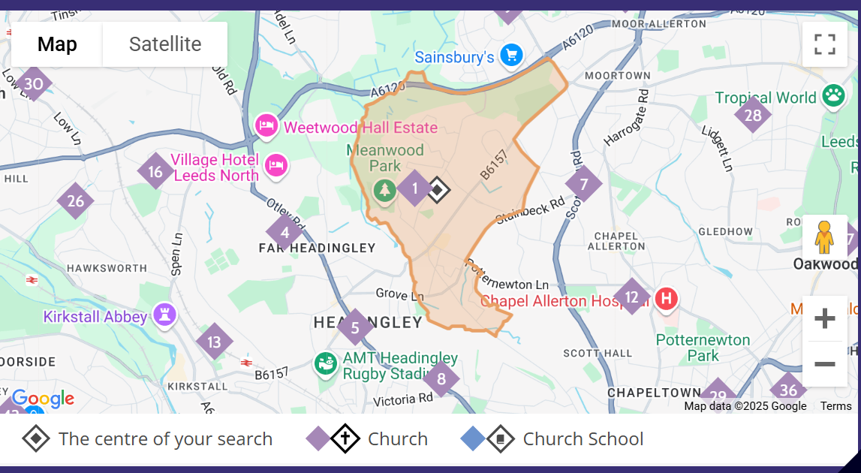

Category 6: Others

Children who do not live in the parish of Holy Trinity Meanwood Church of England church.
Tie-breaker within subscription criteria
- Proximity to the school. We will measure the distance by a straight line. All straight line
distances are calculated electronically using a geographical information system and with the support of the Local Authority where required

- In the event that two or more children live at the same distance from the school (as can happen with families living in blocks of flats), random allocation, where supervised drawing of lots by an independent responsible person of good standing will be used to decide which child(ren) will be allocated the remaining place(s) (in accordance with 1.34 and 1.35 of the School Admissions Code).
Supplementary Information Forms
- Where a Supplementary Information Form is required for the oversubscription criteria this needs to be returned to school before the national closing date of 15 January by a cleric (not by parents). It is the parent’s responsibility to request a reference from their cleric. Those worshipping at Holy Trinity must complete a reference request form. This is attached at the end of this policy.
- If attendance at regular services of worship has taken place at more than one location, a Supplementary Information Form is required from all locations.
- It is parent’s responsibility to ensure that all Supplementary Information Forms are returned to school by the deadline. The Governing Board accepts no responsibility for information that was not supplied to them in time. Where a Supplementary Information Form is not received by the national deadline, applications will be prioritised based solely on the information from the Leeds City Council online application form.
- Where there has been a change in the place of regular worship:

- A Supplementary Information Form must be provided from all relevant places of worship, showing a total of at least two years regular worship
- There must not be a gap in worship exceeding eight weeks.

- The most recent place of worship will determine the priority, provided that to move up the category list to a higher priority:
  - Previous on-Christian worship cannot be added to Christian worship; and
  - There must be evidence of no less than three months worship in the most recent place of worship.
In-Year admissions
All applications outside the normal admission round should be made online at: https://www.leeds.gov.uk/schools-and-education/school-admissions.
The Local Authority admissions team will notify all preference schools about the application. The school will contact you directly to confirm whether they can offer a place. If a place cannot be offered your child will be added to the waiting list.
The school retains waiting lists of unsuccessful applicants in all year groups. The position

Admission of children outside their normal age group

- Parents may request that their child is admitted to a year group outside their normal age range, for instance where the child is gifted or talented or where a child has suffered from particular social or medical issues impacting on their schooling. All such requests will be considered on their merits and either agreed or refused, on that basis. If a request is refused, the child will still be considered for admission to their normal age group.
- The process for requesting such an admission is as follows:
- With the application, parents should request that the child is admitted to another year group (state which one), and the reasons for that request.
- Parents will submit any evidence in support of their case with the application, for instance from a medical practitioner, headteacher etc. Some of the evidence a parent might submit could include:
- information about the child’s academic, social and emotional development;
- where relevant, their medical history and the views of a medical professional;
- whether they have previously been educated out of their normal age group; and/or
- whether they may naturally have fallen into a lower age group if it were not for being born prematurely.
- The school will consider each case on its merits, taking into account the individual circumstances of the request and the child’s best interests. We will also ensure the parent is aware of whether the request for admission out of age group has been agreed before final offers are made, and the reason for any refusal.
- Requests for admission out of the normal year group will be considered alongside other applications made at the same time. An application from a child who would ‘normally’ be a year 1 child for a Reception place will be considered alongside applications for Reception.
Waiting Lists

The school will operate a waiting list for each year group. Where in any year the school receives more applications for places than there are places available, a waiting list will operate until the end of the academic year in which the application was made. A child’s position on the waiting list will be determined solely in accordance with the oversubscription criteria. Where places become vacant they will be allocated to children on the waiting list in accordance with the oversubscription criteria. The waiting list will be reordered in accordance with the oversubscription criteria whenever anyone is added to or leaves it.

Appeals Procedure

All applicants refused a place have a right of appeal to an independent appeal panel constituted and operated in accordance with the School Admission Appeals Code. Appellants should contact Headteacher at Meanwood Church of England Primary School within 20 days of the date of the letter refusing your child a place at the school for information on how to appeal.

Deferred entry for infants

Where a Reception place has been offered at Meanwood Church of England Primary School:
- the child’s parents can defer the date their child is admitted to the school until later in the school year but not beyond the point at which they reach compulsory school age and not beyond the beginning of the final term of the school year for which it was made;
- where the parents wish, the child’s parents may request their child attends part-time until later in the school year but not beyond the point at which they reach compulsory school age.

Compulsory school age is the start of term after the child’s fifth birthday.

Address definition

- Only one address can be used on your application for a school place. The address is the place where the child is permanently resident with his or her parent(s) or legal guardian(s). Evidence may be requested to show the address, and permanence, for example: to which any Child Benefit is paid or at which the child is registered with a medical GP together with recent utilities bill, council tax bill or tenancy agreement. We will investigate any queries about addresses and, depending on what we find, we may change the school place offer.

- Only one address can be used on your application for a school place. Where shared care arrangements are in place, both parents must agree which address will be used on the application, and this should be the address where the child lives for the majority of the school week. If no joint declaration is received by the closing date for applications, the local authority will determine which address will be used, based on where the child spends the majority of the school week. In instances where the child spends equal time with each parent, the home address will be taken as the address where the child is registered with their doctor.

- When we make an offer, we assume your address will be the same when you take up the school place in September. If you plan to move house, you must still use your current address on your application. As soon as you move house, you must tell us your new address, providing proof of your house move (including evidence of entry to the new address and exit from the old address) as this may mean we have to change the school place offer.

- If it is found that an intentionally misleading or false address has been given with the aim of fraudulently securing a school place, that place may be withdrawn, even if the child has already started at the school.
Enquiries

Any enquires should be to sent to the Headteacher at Meanwood Church of England Primary School, Green Road, Meanwood, Leeds, West Yorkshire, LS6 4LD.

MEANWOOD CHURCH OF ENGLAND (VOLUNTARY AIDED) PRIMARY SCHOOL
SUPPLEMENTARY INFORMATION FORM

This section to be completed by parent / guardian
Name of child ...............................................................................................................................
Address ........................................................................................................................................
.......................................................................................................................................................
Parent’s name ………………………………………………………………………………………………………………………..
email ………………………………………………………………………………Telephone ……………………………………………….
Please contact your religious leader and ask them to complete the section below. Those worshipping at Holy Trinity Meanwood must complete a Reference Request Form, available on the church website, www.holytrinitymeanwood.org.uk, and give it to the Vicar with this form. Please note the following clarification about periods of worship, in response to the Covid 19 pandemic:

In the event that during the period specified for attendance at worship the church [or, in relation to those of other faiths, relevant place of worship] has been closed for public worship and has not provided alternative premises for that worship, the requirements of these [admissions] arrangements in relation to attendance will only apply to the period when the church [or in relation to those of other faiths, relevant place of worship] or alternative premises have been available for public worship.

This section to be completed by religious leader
The parent/s of the child named above have applied for a place at Meanwood Church of England Primary School and have given your name as somebody who can vouch for their religious observance. The Governors would be obliged if you would kindly provide the following information:
Has the parent been a regular worshipper (twice per month) at your place of worship? YES / NO
Is the child regularly involved in worship? YES / NO
When did the family start worshipping with you? ……………………………………. (date)
If they are not currently worshipping with you, when did they leave? …………………………………. (date)
Name of religious leader…………………………………………………………………………………………………
Signature …………………………………………………………………………………………………… Date …………………………….
Name of church /place of worship……………………………………………………………………………………………………
Denomination ………………………………………………………………………
Please include a copy of your official letter head or an official stamp on this form.
THIS PAGE MUST BE RETURNED TO SCHOOL BY A RELIGIOUS LEADER, NOT A PARENT / GUARDIAN
Return to: Meanwood Church of England Primary School, Green Road, Leeds, LS6 4LD

School Application
Reference Request
Applies to references for all schools

If you need a church reference to support a school application, please complete this form and hand it to the Vicar after Sunday worship (any service). This face to face meeting on Sunday is an important part of the process, so please don't post or email the form.

The information gathered in this process will help the Vicar to verify attendance and write a fair reference. The process is necessary as we receive a large number of reference requests.

School(s) applied for:

Name of Child: |  |  | DoB:
Your name(s):

Telephone:
Email:
When did you start attending worship at Holy Trinity?

Which service(s) do you attend?

How frequently?

Which groups has your child attended:
Little Mice  Main service  KidzChurch  

